NORTHERN EDUCATION DIVISION
2026 JUNIOR CERTIFICATE MOCK EXAMINATIONS
MATHEMATICS – PROVISIONAL MARKING SCHEME
(100 Marks)
Date: Monday, 11 July 2026 Time allowed: 2 hours
08:00 – 10:00 am

Instructions
- This paper has 13 pages printed. Please check.
- The maximum number of marks for each answer is indicated against each question.
- Write your answers in the spaces provided
- Show all your working.
- Calculators may be used.
- Please make sure that you write your name on top of all pages in this paper before you start answering questions.

Questions answered | Tick if answered | Do not write in this column
1
2
3
4
5
6
7
8
9
10
11
12
13
14
15
16
17
18
19
20
Total

Turn over
- Evaluate $\frac{9}{g}$ + 2h + 5 when g = -3 and h = - 6 ( 3 marks)
$\left(\frac{9}{-3}\right)+2\left(-6\right)+5$ M1 – substitution
-3-12+5 M1 - simplification
-15+5
-10 A1 - accuracy

- Find the difference between 20112₃ and 11121₃ and express your answer in base 10 ( 5 marks)

2 0 1 1 2₃
- 1 1 1 2 1₃ M1 – subtraction
1 2 2 1₃ M1 – finding difference
1221₃ = 1 x3³ + 2x 3² + 2x3¹ + 1 x 3⁰ M1- converting to base 10
= 27 + 18 + 6 +1 M1- simplification
= 52 A1 – correct answer
NB: For candidates who use alternative by converting to base 10, then subtraction, their marks to be awarded in the order: expanding in base 10, simplification, writing number in base 10, subtraction, accuracy.

- Table 1 shows temperature readings in degrees Celsius of the four cities of Malawi in June:
Table 1
City | Temperature(℃)
Zomba | -2
Blantyre | 4
Lilongwe | 13
Mzuzu | -3

Calculate the mean temperature of the four cities on that day. (4 marks)

Mean =$\frac{-2+4+13-3}{4}$ M1 – applying mean formula

$=12/4$ M1 M1 – directed numbers, simplification
$=3$ A1 - accuracy

- Mr Mwale bought a plot at K2,000,000 in 2024. If the value of the land appreciates at 3% per annum and he decides to sell the plot at the end of 2026, how much will this plot cost? (5 marks)

2024 : 2,000,000
2025 = 2,000,000 + (3/100 x 2,000,000) M1 – appreciation in first year
= 2,060,000 M1- value of land after 1 year

2026 = 2,060,000 + (3/100 x 2,060,000) M1 – appreciation in second year
= 2,121,800 M1 A1 – value of land after 2 years, accuracy

- A teacher wrote the numbers from 10 to 20 on number cards and asked Watipaso to select a card at random. Determine the probability that the number of the card picked is a prime number. (4 marks)

Sample space = $10,11,12,13,14,15,16,17,18,19,20$ M1- sample space
Number of cards together = 11
P(prime) = 3/11 M1 – favourable outcome (identifying prime numbers)
M1 – finding probability
A1 - accuracy

- Solve the following simultaneous equations:

$x-y=3$
$3x+y=1$ (5 marks)

$x-y=3$ M1 – addition in order to eliminate y
+$3x+y=1$
$4x=4$
$x=1$ M1 – value of x
$3\left(1\right)+y=1$ M1 – substitution into one of the 2 equations
$y=1-3$ M1 - simplification
$y=-2$ A1 – value of y

- Figure 1 shows two isosceles triangles ABD and ACD with the same base, AD.
B

$32°$

C
$64°$
$x$

A D
Figure 1
Given that AB = DB, and AC = DC. Angle ABD = $32°$, and angle ACD = $64°$, calculate the value of angle marked $x$. (6 marks)

$64°+angle CAD+angle ADC=180°$ M1 – applying angle sum of triangle
But $angle CAD=ADC$
Then $64°+2angleCAD=180°$ M1 – applying base angles of isosceles triangle
$2angle CAD=180°-64°$
$=116°$
$angle CAD=\frac{116°}{2}$ = $58°$ M1- finding angle CAD
Likewise,
$32°$+ angle BAD + angle ADB = $180°$
Angle BAD = angle ADB (base angles)
$32°+2 angle BAD=180°$
$2 angle BAD=180°-32°=148°$
$angle BAD=\frac{148}{2}=74°$ M1 – finding angle BAD
$x=74°-58°$ M1 – finding x
$=16°$ A1 - accuracy
- Make $n$ the subject of the formula $d=\frac{t(n-1)}{n}$ (5 marks)
$dn=t(n-1)$ M1 –multiplying by n
$dn=tn-t$ M1 - expanding
$t=tn-dn$
$t=n(t-d)$ M1 - factorisation
$n=\frac{t}{t-d}$ M1A1 – division and accuracy

- Given that the point $\left(p,4\right)$lies on a straight whose equation is
$y=2x+3$. Find the value of $p$ (4 marks)

$4=2p+3$ M1 - substitution
$4-3=2p$ M1 – collecting like terms
$1=2p$ M1 - simplification
$p=\frac{1}{2}$ A1 - accuracy

- Solve for $x$ in the equation $\frac{x-2}{5}-\frac{x+5}{6}=1$ (5 marks)
$\frac{30(x-2)}{5}-\frac{30\left(x+5\right)}{6}=30(1)$ M1 – multiplying throughout by common denominator
$6\left(x-2\right)-5\left(x+5\right)=30$ M1 - cancellation
$6x-12-5x-25=30$ M1 – collecting like terms
$x-37=30$ M1 - simplification
$x=67$ A1 - accuracy

- Figure 2 is a venn diagram showing rivers in Kasungu and Mchinji.

KASUNGU MCHINJI

Mpasadzi Bua Tovi
Rusa Likase

Figure 2
a) List down rivers in the union of sets Kasungu and Mchinji. (2 marks)

$Mpasadzi,Bua,Rusa,Tovi,Likase$ M1A1 – identifying elements in union (at least 3 correct), accuracy

b) How many rivers are in the Mchinji set? (1 mark)
$4$ B1
- Find the LCM of $5a^{2}$, $10ab^{2}$ and $15a^{3}b^{3}$ (4 marks)

$5a^{2}=5XaXa$ M1 – expressing a term into factors
$10ab^{2}=2X5XaXbXb$
$15a^{3}b^{3}=3X5XaXaXaXbXbXb$
LCM $=2X3X5XaXaXaXbXbXb$
$=30a^{3}b^{3}$ M1M1A1 – selecting terms without repeatition
- $multiplication$
- Accuracy

- Solve the inequality $\frac{3}{4}x+12>6$ (4 marks)

$\frac{3}{4}x>6-12$ M1 – collecting like terms
$\frac{3}{4}x>-6$ M1 - simplification
$3x>-24$ M1- multiplication/division by denominator
$x>-8$ A1 - accuracy

- How many kilograms of soil supplement that cost K15,000 per kg must be mixed with 20 kg of aluminium nitrate that costs K7,000 per kg to make a fertilizer that cost K9,000 per kg? (Leave your answer correct to the nearest kg). (7 marks)
Component | kg | Cost/kg | Total cost
Soil supplement | $$x$$ | 15,000 | 15,000$x$
Aluminium nitrate | 20 | 7,000 | 140,000
Fertilizer (mixture) | $$x+20$$ | 9,000 | 9000($x+20)$
M1 – cost of soil supplement
M1 – cost of aluminium nitrate
M1 – cost of mixture

9000$\left(x+20\right)=15000x+140000$ M1 – equating total costs
9000$x+180000=15000x+140000$ M1 - simplification
-6000$x=-40000$
$x=6.7$ A1 - accuracy
$=7kg$ B1 (to the nearest kg)

- A cyclist travelled from town A to town B at an average speed of 20 km/h and took 1.5 hours. On the return journey, due to traffic, she took 30 minutes more. What was her average speed on the return journey? (4 marks)

Return time = 1.5h +0.5 h = 2 h M1- finding return time

Using proportion,
1.5 h corresponds to 20km/h
Then 2 h shall correspond to ….? (more - inverse)
= $\frac{2h}{1.5h}X 20\frac{km}{h}$ M1M1 – applying inverse proportion, and simplification
= 30 km/h A1 - accuracy
Or candidates may first find distance, then calculate speed using new return time and the distance.

- Factorise completely $6x^{2}-6.$ (3 marks)

$6(x^{2}-1)$ M1 – taking out common factor
$6(x+1)(x-1)$ M1A1 – applying difference of squares, accuracy

- Use logarithms to evaluate $\frac{5.4 X 0.0064}{0.086}$, give your answer correct to 2 decimal places. (5 marks)

number | log
5.4 | 0.7324
0.0064 | -2.1938
add | -1.4614
0.086 | -1.0655
subtract | -0.3959
antilog | 0.4019

= 0.40
M1 – finding log of a number
M1- applying law of multiplication or division
M1 – finding antilog
A1- accuracy
B1 – to 2 dp

- Figure 3 is a pie chart showing students who play different games.

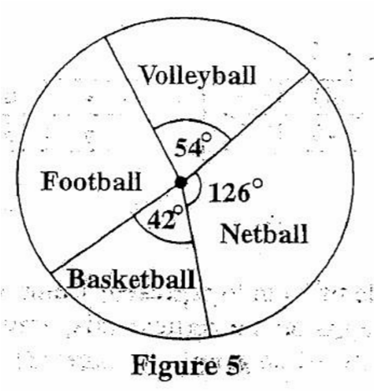
Figure 3
If the total number of students is 60, calculate the number of students who play football. (5 marks)

$f+54°+126°+42°=360°$ M1 – applying angles at a point
$f=360°-222°=138°$ M1 – finding angle for football
$f=\frac{138}{360}X60$ M1 M1 – expressing fraction of angle, finding number of f
$=23$ A1 – accuracy

- Figure 4 is a diagram of a right pyramid.

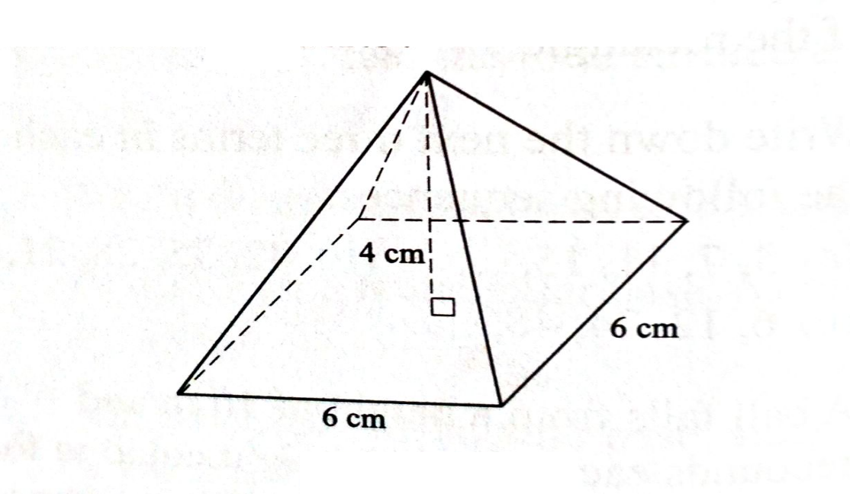
Figure 4
Calculate its total surface area. (10 marks)

Diagonal, d² = 6² +6²= 72 M1
d = $√72$
1/2d = $\sqrt{72}/2$ M1
The slant height l² = 4² +$\left(\frac{\sqrt{72}}{2}\right)2$ M1
= 16 + (72/4)
l² = 16 +18 = 34 M1
Height of each triangle = l² - 3² = h2 M1
= 34 – 9 = 25 = h²
h = $\sqrt{25}$ = 5 M1
Surface area of pyramid = 6x6 + 4 ( ½ x 6x5) M1M1
= 36 +60 M1
= 96cm² A1

- a) Complete the tables of values for the equations $y=5-2x$
and $y=x-4$ (2 marks)

𝒚 = 𝟓 − 𝟐𝒙
 | −1 | 2 | 5
 | 7 | 1 | −5

$y=x-4$
$$x$$ | -1 | 2 | 5
$$y$$ | -5 | -2 | 1

B1B1
b) Using a scale of 2 cm to represent 1 unit on both axes, draw graphs of $y=5-2x$ and $y=x-4$ on the graph provided (5 marks)
M1 – scale (at least one correct scale)
M1 – plotting points
M1 – drawing first line
M1 – drawing second line
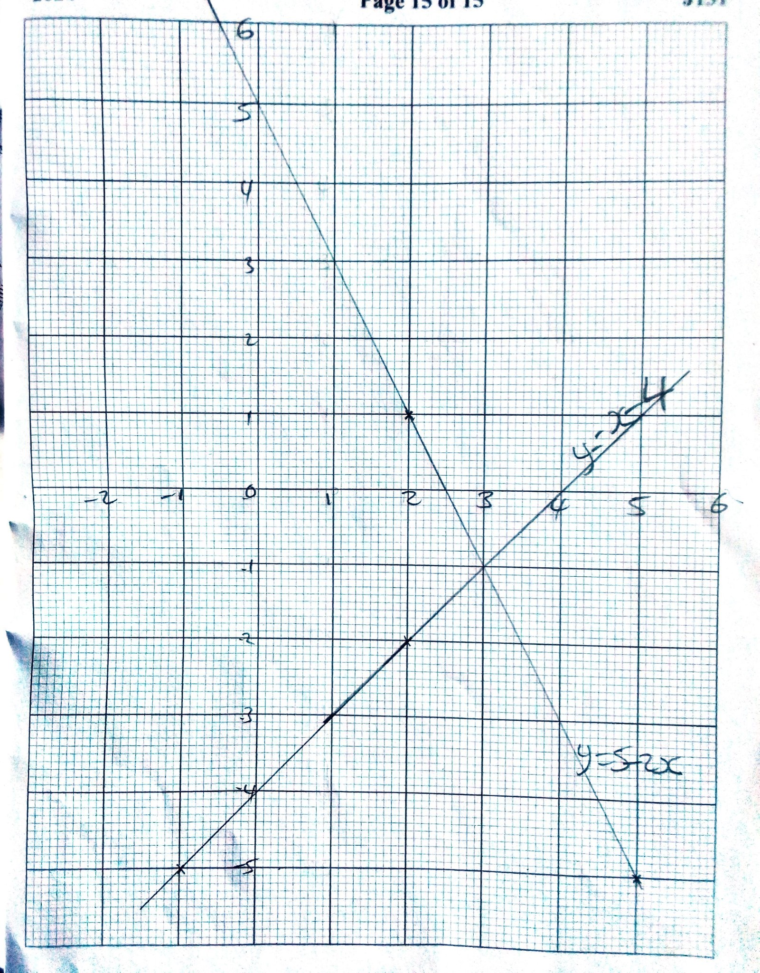
A1 - accuracy

c) Use the graphs to solve the simultaneous equations $y=5-2x$ and $y=x-4$ (2 marks)

$x=3, y=-1$ B1B1

END OF QUESTION PAPER

